Maximum marks for Assignment: ____8 Assignment Declaration Date: 08/9/2025
Assignment Submission Date: (12/9/2025) Assignment assessment declaration Date by faculty: (12/9/2025)

Q.NO | Question Statement | Level of mapping & NO. |  |  | Blooms Level | Mark
Q.NO | Question Statement | CO | PO | PSO | Blooms Level | Mark
Q1 | Explain the Process control block with a suitable diagram | CO4 | PO1 | PSO1 | 2 | 4
Q2 | Draw and explain the Process state transition diagram with 5-state models and 7-state models. Differentiate between these 2 models. | CO4 | PO1 | PSO1 | 2 | 8
Q3 | What is a thread? Define User Level Thread (ULT) and Kernel Level Thread (KLT). Explain the thread lifecycle with a diagram. | CO4 | PO1 | PSO1 | 2 | 6
Q4 | Consider the following processes. Calculate average TAT & WT  i) Draw Gantt chart to show the execution using SJF Preemptive, non-preemptive priority (small number implies higher priority) | CO4 | PO3 | PSO2 | 3 | 5
  Processes | P1 | P2 | P2 | P4 | P5
  BT | 3 | 5 | 2 | 2 | 5
  Priority | 3 | 1 | 3 | 4 | 2
  Arrival Time | 0 | 1 | 3 | 9 | 12
Q5 | Explain types of schedules. Short Term, Long Term, Medium Term | CO4 | PO1 |  | 2 | 6
Q.6 | Explain the concept of a thread. Draw and explain the life cycle of thread. | CO4 | PO1,2 | PSO1 | 1 | 4
Q.7 | Consider the following processes where Time slice= 1 Sec  Draw Gantt chart to show the execution using RR and preemptive priority (small number implies higher priority), calculate ATAT & AWT | CO4 | PO2 | PSO2 | 3 | 6
  Processes | P1 | P2 | P2 | P4 | P5
  BT | 8 | 6 | 1 | 2 | 5
  Priority | 1 | 2 | 3 | 0 | 4
  Arrival Time | 0 | 0 | 2 | 3 | 1
Q.8 | What is an operating system? What are the basic services and functions of an operating system? | CO4 | PO1 |  | 2 | 5
Q.9 | Explain the process and threads in detail. List the benefits of using threads | CO4 | PO1 |  | 2 | 4
Q.10 | What is a real-time operating system? Explain its types with suitable examples? | CO4 | PO1 |  | 2 | 4
Q.11 | What is an Operating System? Draw and explain a layered approach with advantages and disadvantages. | CO4 | PO1 |  | 1 | 6
Q.12 | Differentiate between preemptive and non-preemptive types of scheduling? | CO4 | PO1 |  | 4 | 6
Blooms level no | Blooms Taxonomy terms
6 | 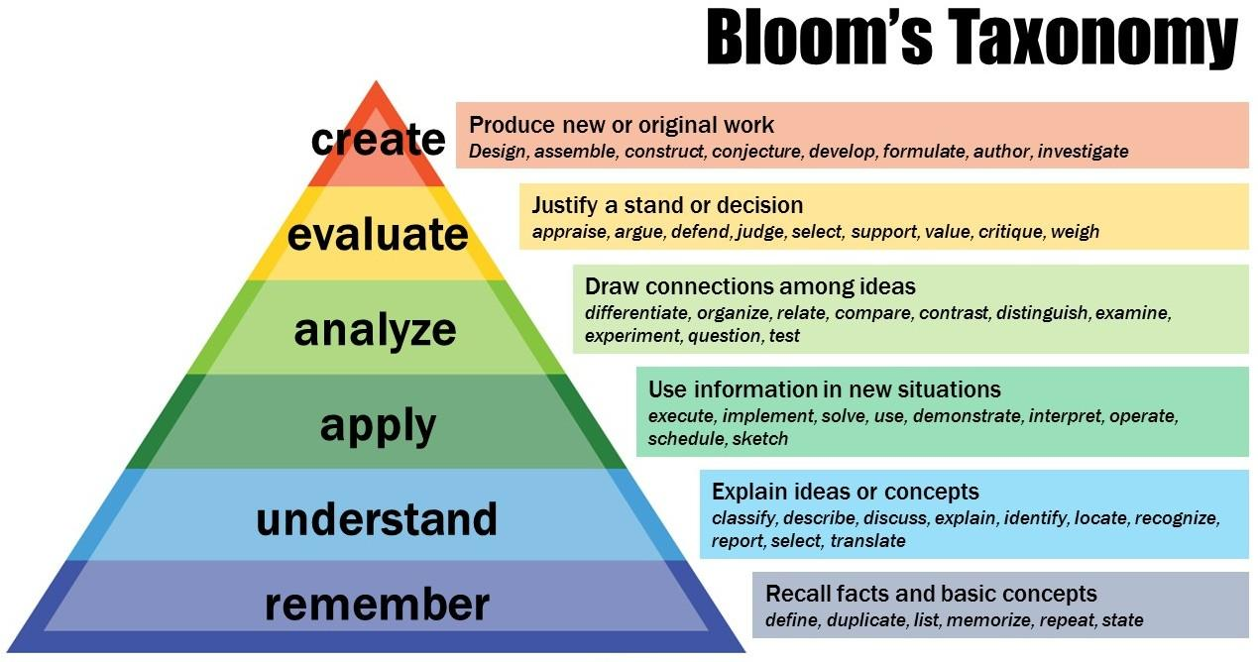
5
4
3
2
1
Subject In-charge HOD

